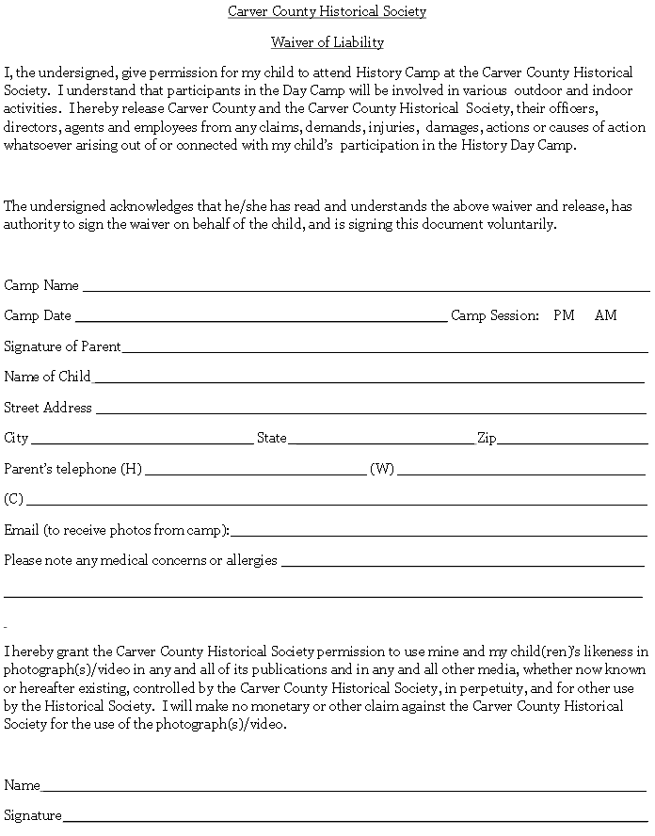



Please mail completed registration form and payment to:

Carver County Historical Society

555 West First Street

Waconia, MN 55387

Space is limited to 10 children for each camp to provide the best possible experience for your children. Accommodations will be made for siblings who would like to attend together. Please note Summer History Day Camps offer craft activities using natural materials, please note any allergies or dietary exceptions for your child on the liability waiver. For more information please call Miles Jewell at (952) 442-4234. The Carver County Historical Society reserves the right to cancel if fewer than 3 children register. Please return this registration form with your liability waiver and photo release forms.

**Registration Information**

Child’s Name: ______________________________ Age: ______ Grade: _______

Child’s Name: ______________________________ Age: ______ Grade: _______

Child’s Name: ______________________________ Age: ______ Grade: _______

Child’s Name: ______________________________ Age: ______ Grade: _______

Address: _____________________________­­­­­­­­­­­­­­­­­­­­­­­­­­­___________________________

Phone Number: ___________________________________________________

Parent's Name: ___________________________________________________

Please select which camp(s) your child(ren) will be attending, which session, and how many in each session. Member Non-member

**___ Pioneer Camp, June 7th (ages 6 - 12)** $50 $60

____**Lumberjack Camp, June 8th (ages 8 - 14)** $50 $60 ____**Civil War Camp, June 9th (ages 8 - 14)** $50 $60

**____Voyageur Camp, June 10th (ages 8 - 14)** $50 $60

Amount enclosed: ___________________________________________

*(Please make checks payable to the Carver County Historical Society.)*

History Day Camp Registration